Three level models for continuous and dichotomous outcomes

SPSS syntax gives a few examples.

three level model for continuous outcome

GENLINMIXED

/DATA_STRUCTURE SUBJECTS=school*classroom*student_id

/FIELDS TARGET=posttest TRIALS=NONE OFFSET=NONE

/TARGET_OPTIONS DISTRIBUTION=NORMAL LINK=IDENTITY

/FIXED EFFECTS=school_setting school_type teaching_method n_student

gender lunch pretest

USE_INTERCEPT=TRUE

/RANDOM USE_INTERCEPT=TRUE SUBJECTS=school

COVARIANCE_TYPE=VARIANCE_COMPONENTS

/RANDOM USE_INTERCEPT=TRUE SUBJECTS=school*classroom

COVARIANCE_TYPE=VARIANCE_COMPONENTS

/BUILD_OPTIONS TARGET_CATEGORY_ORDER=ASCENDING

INPUTS_CATEGORY_ORDER=ASCENDING MAX_ITERATIONS=100

CONFIDENCE_LEVEL=95 DF_METHOD=RESIDUAL COVB=MODEL

/EMMEANS_OPTIONS SCALE=ORIGINAL PADJUST=LSD.

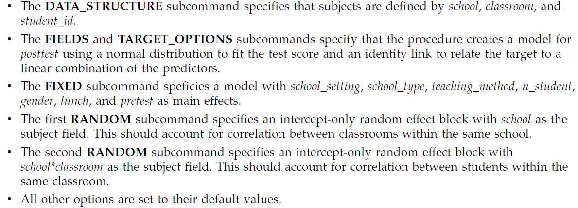

Also, the manual shows a logistic regression example:

GENLINMIXED

/FIELDS TARGET=default

/TARGET_OPTIONS DISTRIBUTION=BINOMIAL LINK=LOGIT

/FIXED EFFECTS=age ed employ address income debtinc creddebt othdebt.

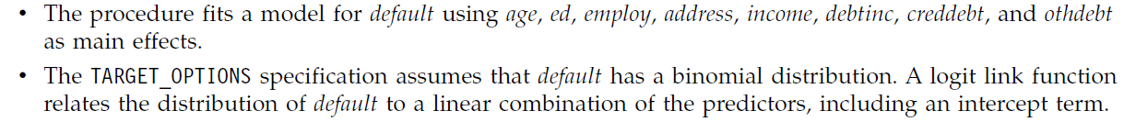

Combining these gives:

GENLINMIXED

/DATA_STRUCTURE SUBJECTS=school*classroom*student_id

/FIELDS TARGET=response

/TARGET_OPTIONS DISTRIBUTION=BINOMIAL LINK=LOGIT

/FIXED EFFECTS=school_setting school_type teaching_method n_student

gender lunch pretest

USE_INTERCEPT=TRUE

/RANDOM USE_INTERCEPT=TRUE SUBJECTS=school

COVARIANCE_TYPE=VARIANCE_COMPONENTS

/RANDOM USE_INTERCEPT=TRUE SUBJECTS=school*classroom

COVARIANCE_TYPE=VARIANCE_COMPONENTS

/BUILD_OPTIONS TARGET_CATEGORY_ORDER=ASCENDING

INPUTS_CATEGORY_ORDER=ASCENDING MAX_ITERATIONS=100

CONFIDENCE_LEVEL=95 DF_METHOD=RESIDUAL COVB=MODEL

/EMMEANS_OPTIONS SCALE=ORIGINAL PADJUST=LSD.

Note:

* As the /DATA_STRUCTURE SUBJECT= … gives the independent ‘subjects’ I can also guess that it has to be: /DATA_STRUCTURE SUBJECTS=school*classroom   
  As the student level is handled by the binary response.
* Two random effects are specified: for school and for classroom within school. The latter is denoted by school*classroom.